The Simplest Version:
Micro:bit’s LEDs Screen & Buzzer, MQ2 = P0
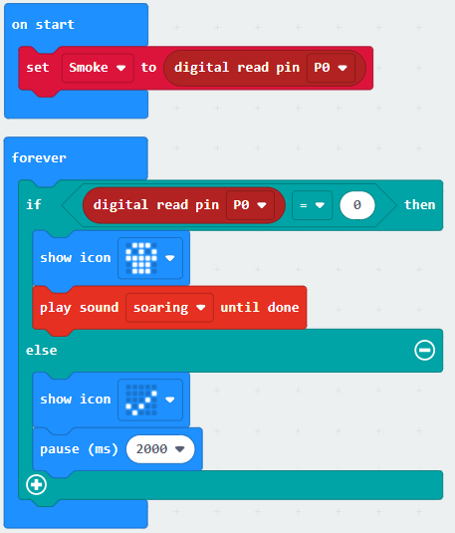

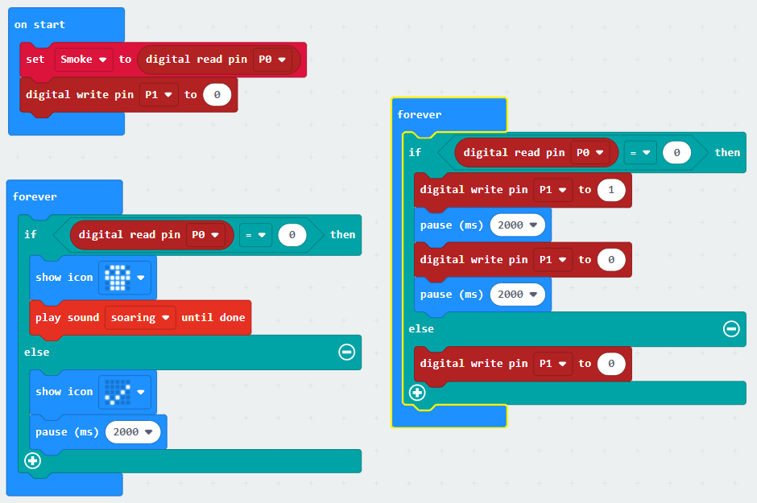

2nd Version:
Micro:bit’s LEDs Screen & Buzzer, MQ2 = P0,
LED lightbulb (Flashing) = P1

3rd Version:
Micro:bit’s LEDs Screen & Buzzer, MQ2 = P0,
LED lightbulb (Flashing) = P1, Water Pump (With relay) = P2
