[SCW] Lab manual for Artificial Cloud
Introduction
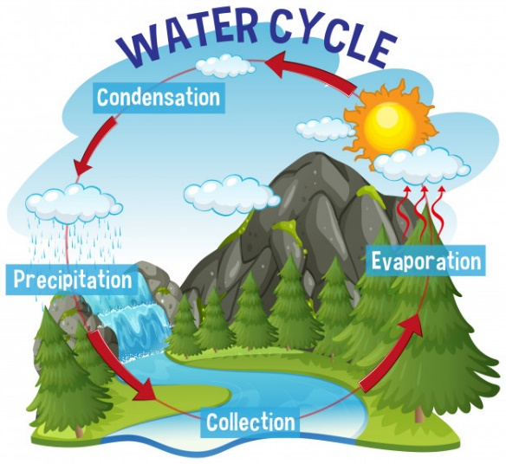
Clouds are created when water vapor turns into liquid water droplets. These water droplets form on tiny particles, like dust, that are floating in the air. With the accumulation of water droplets on tiny particles, cloud droplets will be visible.
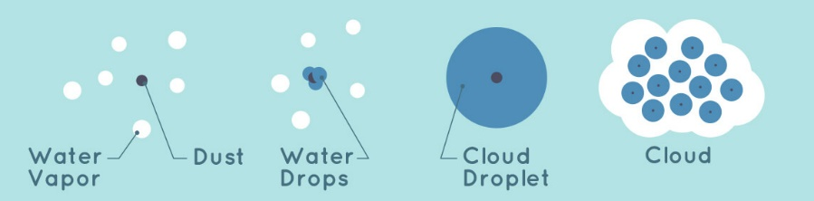
In the atmosphere, tiny particles come from erupting volcanoes, wildfire, and emission of air pollutant (e.g. NO₂, SO₂) which leads to acid rain. In this experiment, joss sticks are lighted up to simulate the emission of tiny particles in nature.

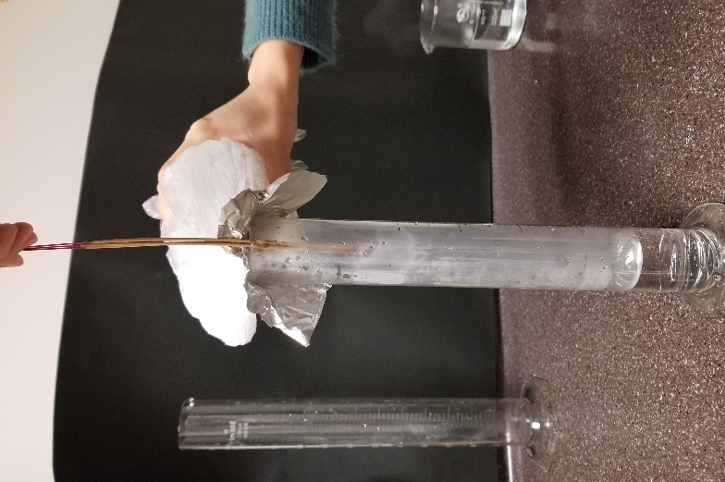
Equipment list:
Item(s) | Number | Per set
500 mL measuring cylinder | (depends on the number of set) | 1
Hot water (~70°C) | (depends on the number of set) | 100 mL
Plastic wrap/ Aluminum foil | (depends on the number of set) | 10 cm²
Ice | (depends on the number of set) | 10 X 7cm³(ml)
Plastic bag (container for ice) | (depends on the number of set) | 1
Joss stick (thin) | (depends on the number of set) | 3
Lighter | 1 | 1

Procedure
- Fill 100 mL hot water (~70°C) into the 500 mL measuring cylinder
- Light up three joss sticks and put them into the cylinder
- Cover the cylinder with plastic wrap
- Put ice on the top of plastic wrap for cooling
- Hold the glowing joss sticks for 30 seconds
- Put away the joss sticks, remain the cylinder covered
- Hold the ice on the top of plastic wrap for 4 minutes and 30 seconds
- Put away the ice and the plastic wrap
- Observe

